

**Cloud Deployment Models**

**Name:** Pratham Kandari

**Sap Id:** 500097663

**Batch:** 7

**LAB 2**

**Openstack Installation & Dashboard**

Step 1: Use the beta channel. Initialization step automatically deploys, configures, and starts OpenStack services. In particular, it will create the database, networks, an image, several flavours, and ICMP/SSH security groups.

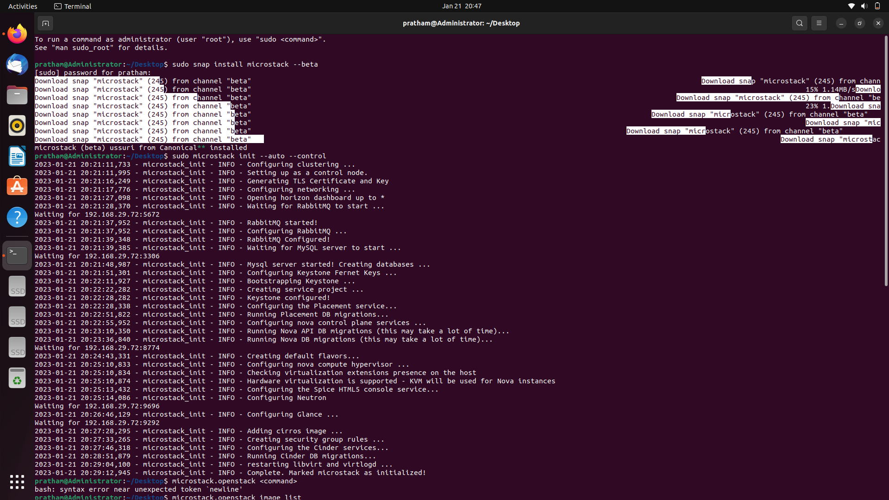

Step 2: To list the default image. Next is to get the default list of flavours. To create an instance named ‘test’ based on the ‘cirros’ image. And at last connect to the instance.

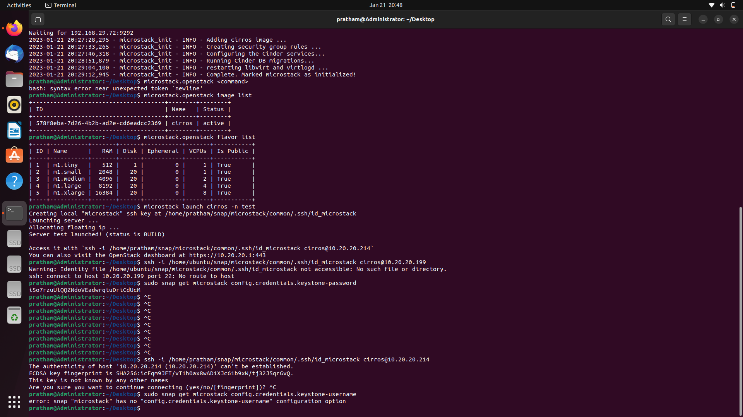

Step 3: OpenStack Dashboard loads up.

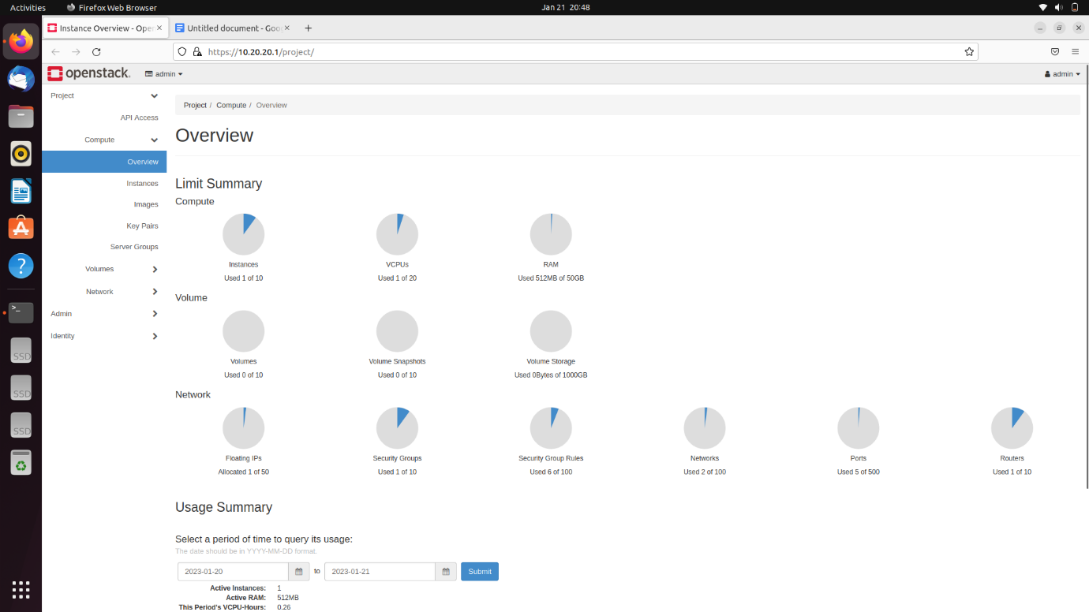

Step 4: See if the created instance is available or not.

